TOOLS USED

MICROSOFT EXCEL, MICROSOFT WORD | PYTHON

ORANGHIS ENROLLMEENT ANALYSIS

A COMPARATIVE ANALYSIS OF ALL ORANGHIS ENROLLEES FOR EACH LOCAL GOVERNMENT

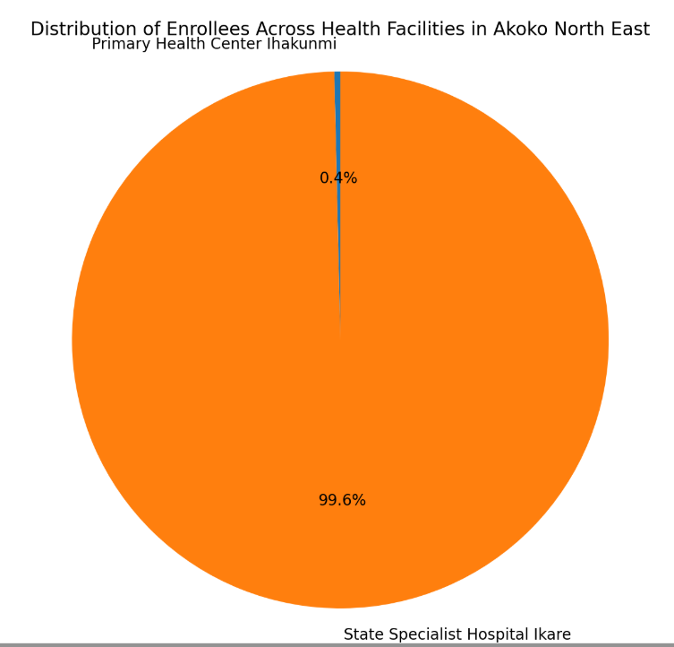**AKOKO NORTH EAST**

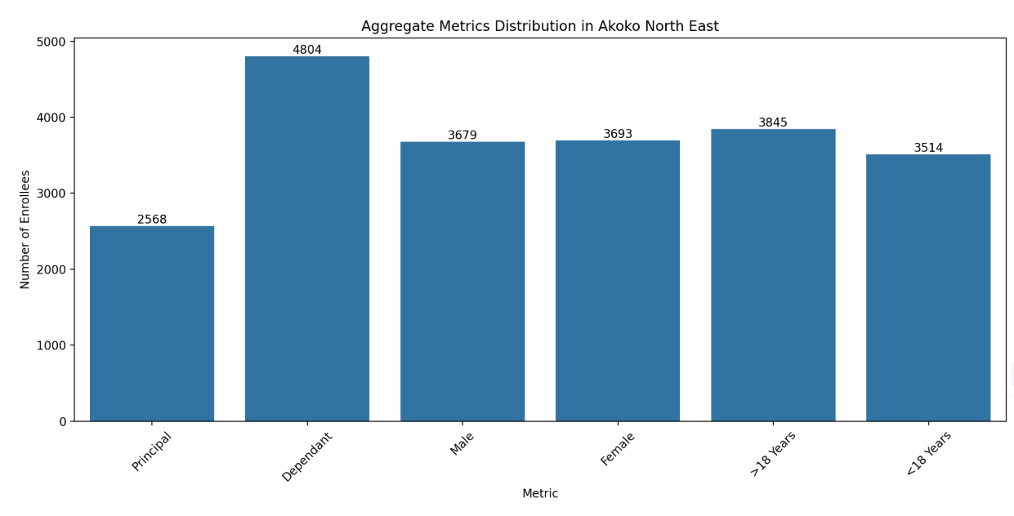

Key insights:

1. State Specialist Hospital Ikare has significantly higher enrollment compared to PHC Ihakunmi, indicating a preference or better accessibility to the specialist hospital.
2. Dependants form the largest category of enrollees, highlighting the need for family-focused health insurance plans.
3. Female enrollees outnumber male enrollees, indicating better outreach to women.
4. A significant proportion of enrollees are over 18 years, indicating a focus on adult health services.

**AKOKO NORTH WEST**

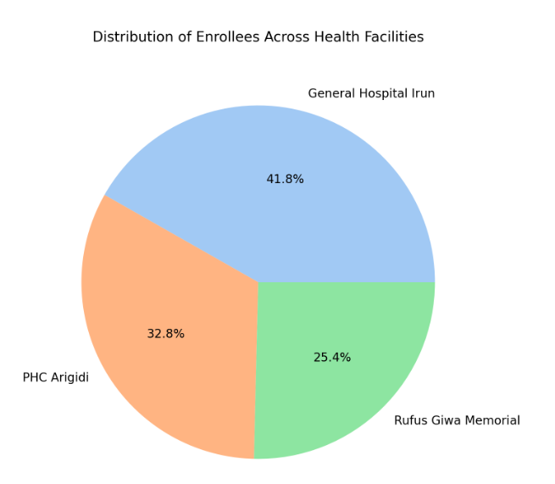

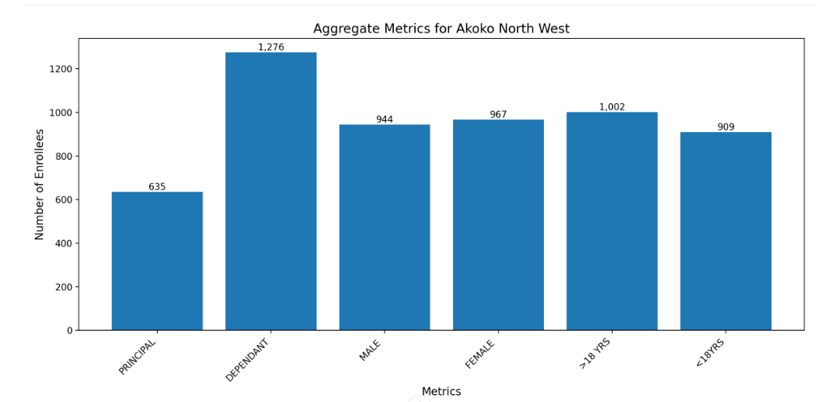

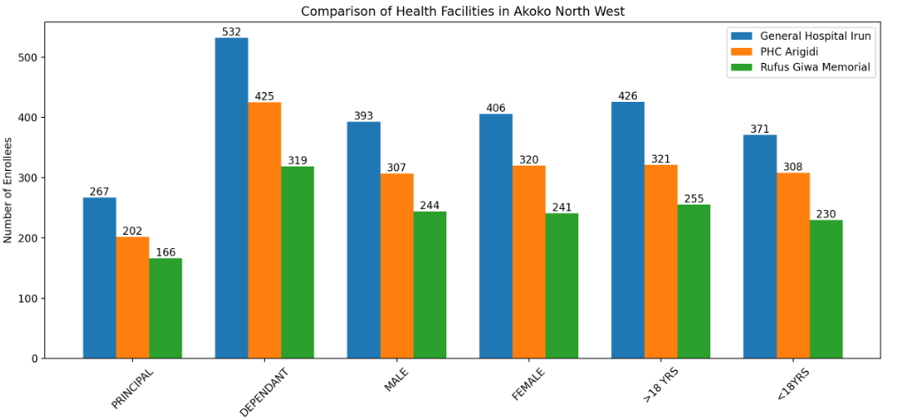

Key Insights

1. The total number of dependants (1276) is significantly higher than principals (635), indicating a high dependency ratio (2:1).
2. The gender distribution is relatively balanced, with 944 males and 967 females.
3. The age distribution shows a slightly higher number of individuals above 18 years (1002) compared to those below 18 years (909).
4. Public health programs should focus on addressing the needs of dependants, as they form the majority of enrollees.
5. Health insurance schemes should consider the high dependency ratio when designing premium structures and coverage plans.

**AKOKO SOUTH EAST**

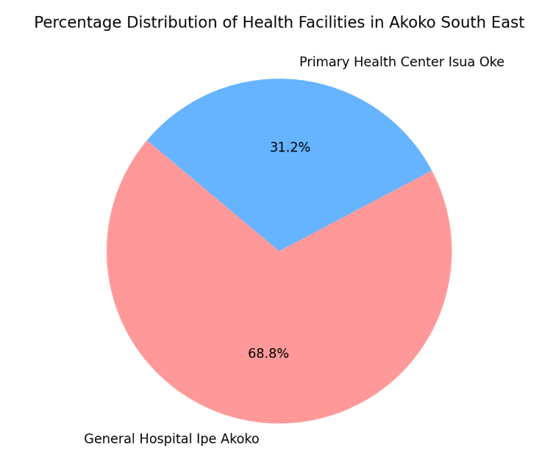

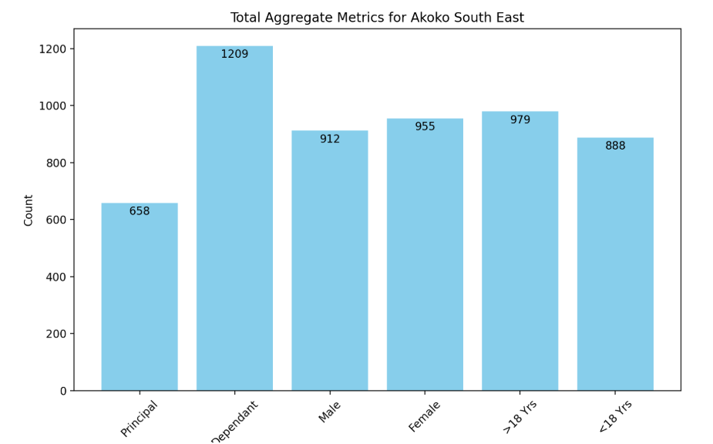

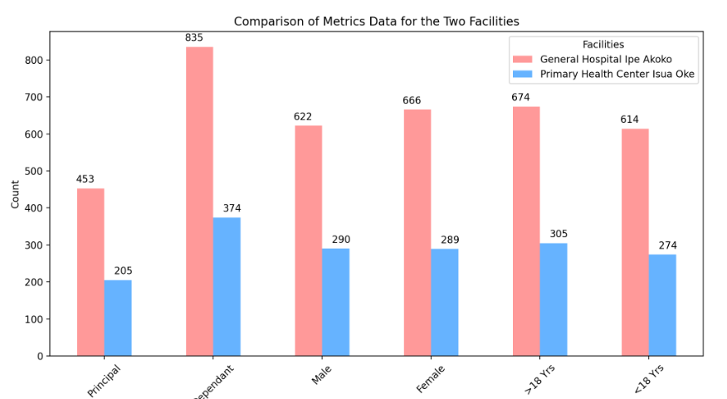

Key Insights:

1. The General Hospital Ipe Akoko handles a significantly larger share of patients compared to PHC Isua Oke, indicating a potential need to redistribute resources or improve PHC services to balance the load.
2. The high number of dependants compared to principals in both facilities highlights the importance of family-based health insurance plans.
3. The females (955) had slightly higher population than males(912)
4. The total metrics indicate that both facilities combined serve a substantial population, emphasizing the need for adequate funding, staffing, and infrastructure to meet healthcare demands.

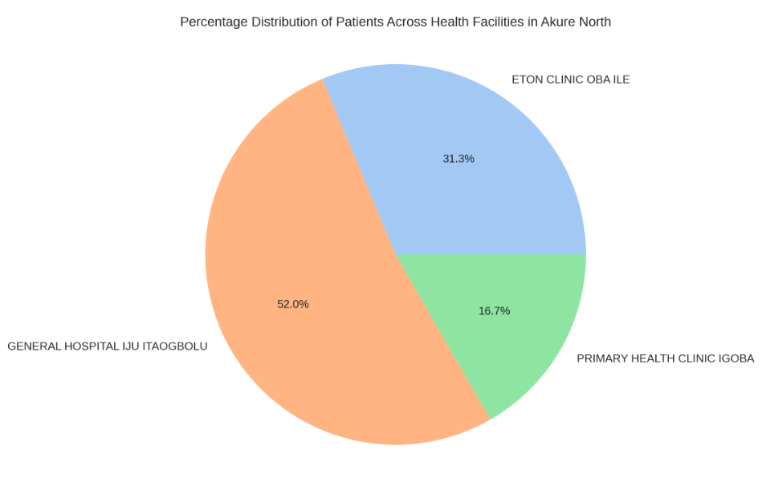**AKURE NORTH**

The pie chart shows the distribution of patients across the three health facilities:

* General Hospital Iju Itaogbolu serves the largest portion (52.0%)
* Eton Clinic Oba Ile handles 31.3%
* Primary Health Clinic Igoba serves 16.7%

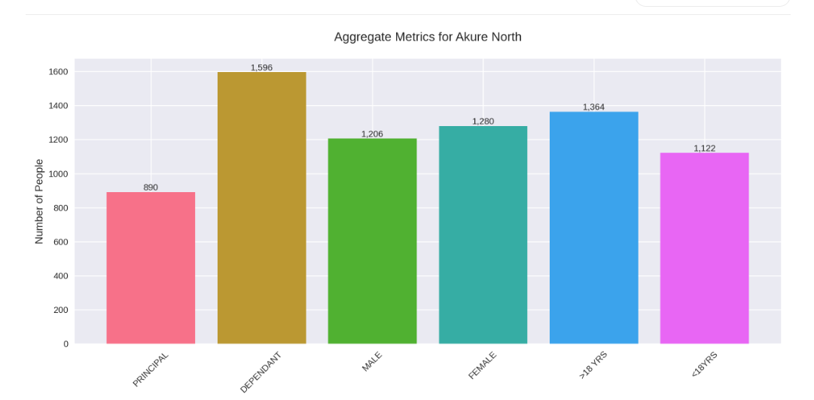

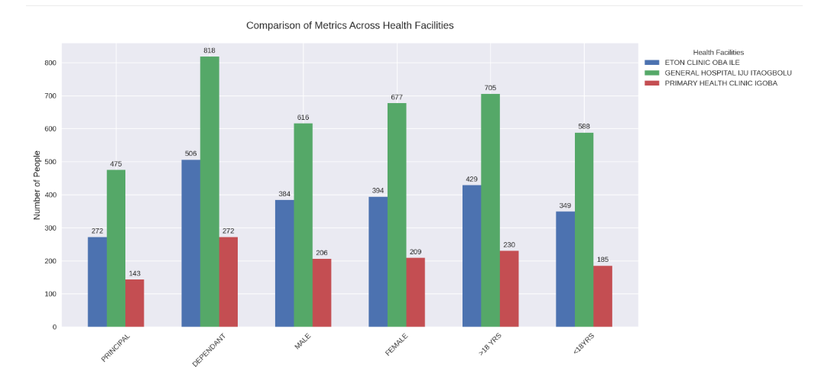

Key Insights

1. Total Dependants (1,596) exceed Principals (890)
2. There's a slight gender skew with more Females (1,280) than Males (1,206)
3. Age distribution shows more people above 18 years (1,364) than below 18 years (1,122)
4. General Hospital Iju Itaogbolu consistently has the highest numbers across all metrics
5. Primary Health Clinic Igoba has the lowest numbers, suggesting it is serving a smaller community
6. The ratio of dependants to principals is roughly consistent across facilities (approximately 2:1)
7. High dependant numbers across facilities suggest family oriented coverage.

**AKURE SOUTH**

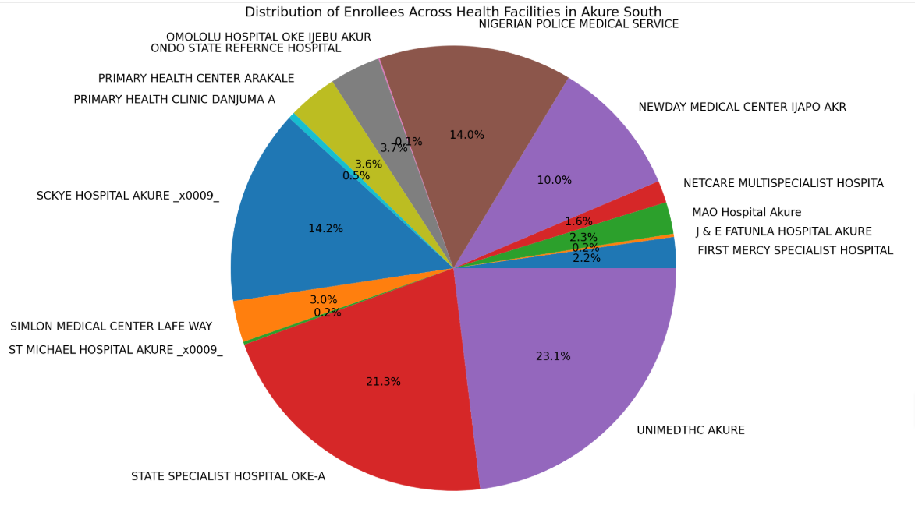

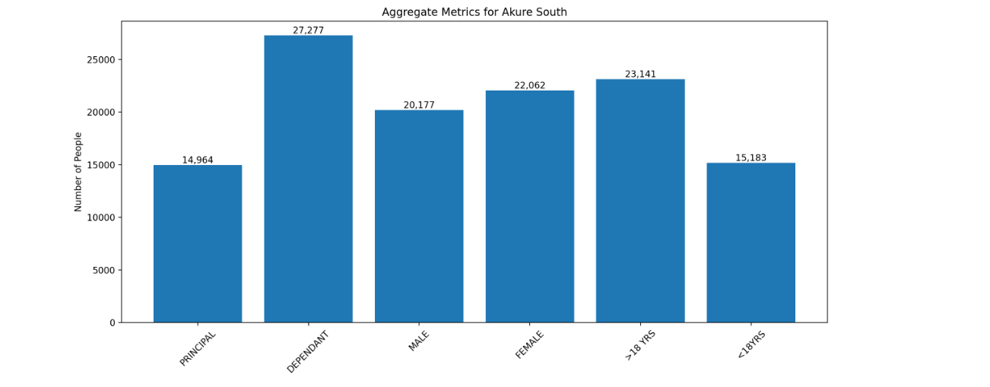

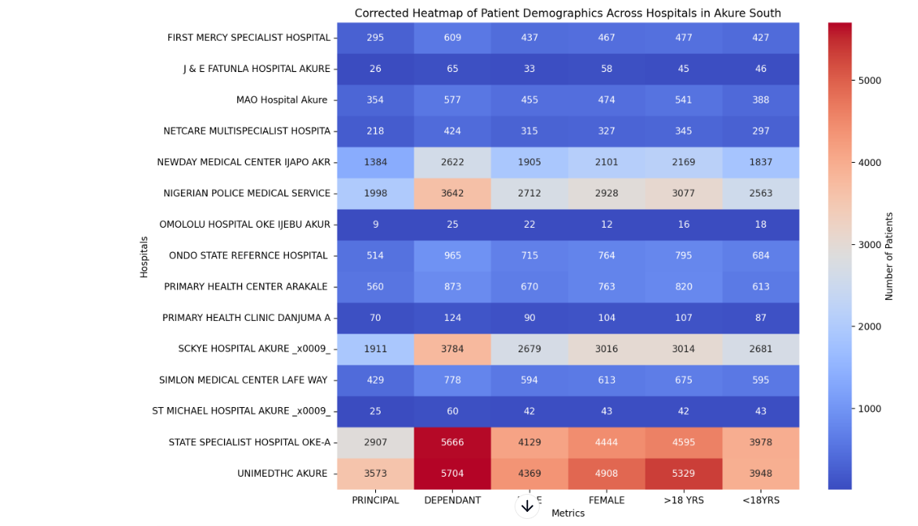

Key insights:

1. In Akure south we had a total of 42,241 in which 27,277 were dependents which accounts for a significant chunk of total enrollees.
2. Unimedth (23.1%), state specialist hospital oke aro (21.3%) and sckye hospitals (14.2%) account for the most enrolled.
3. Across all facilities there was more dependant that principal which indicate a family focused care.
4. There was a significant difference between the those above 18(23,141) and those below 18(15,18) across all facilities.

**ODIGBO**

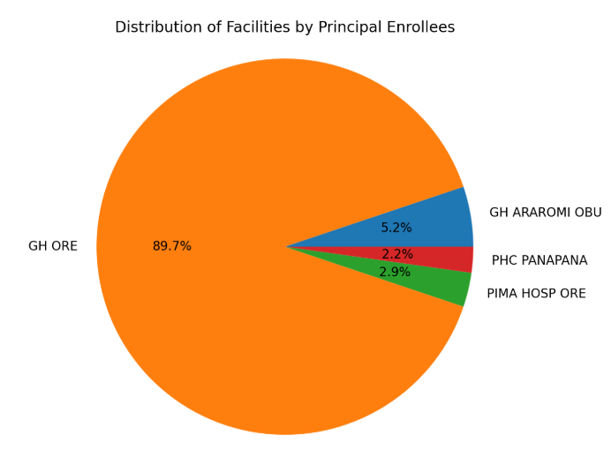

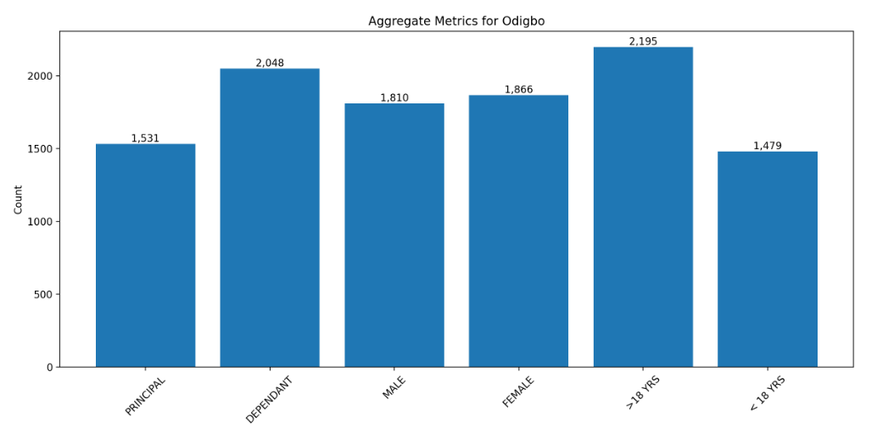

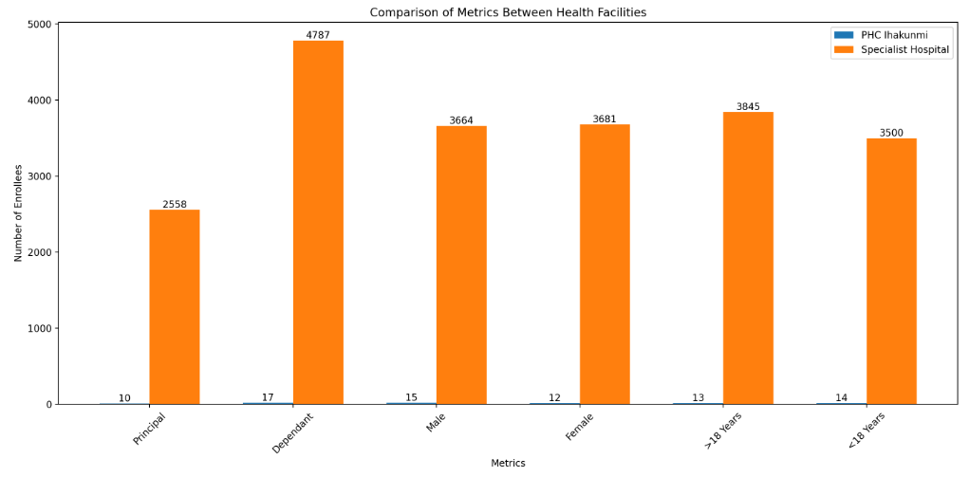

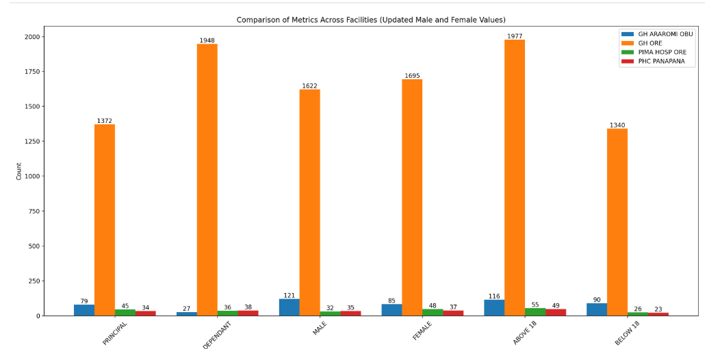

Key Insights:

1. GH ORE dominates with about 89% of principal enrollees
2. Gender distribution is relatively balanced across facilities
3. Adult enrollees (>18) constitute majority across all facilities
4. GH ORE shows highest dependant-to-principal ratio

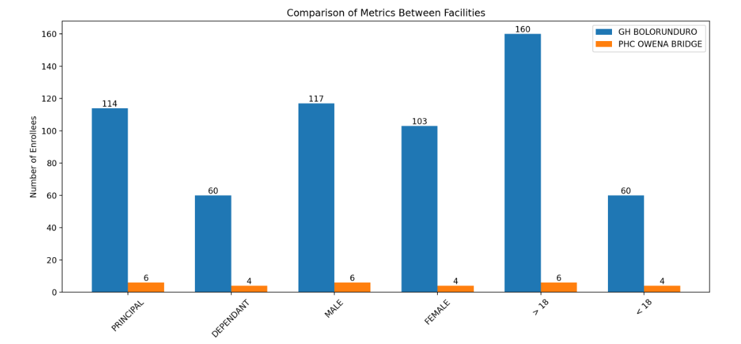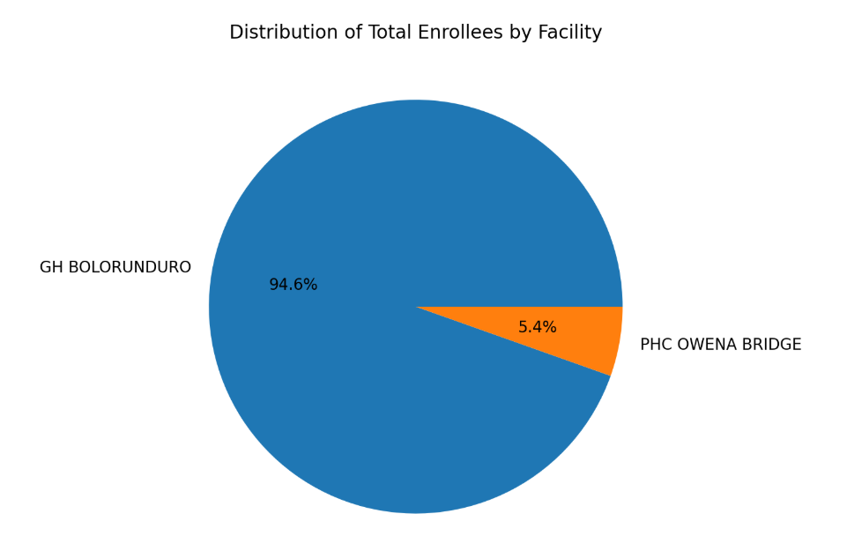**ONDO EAST**

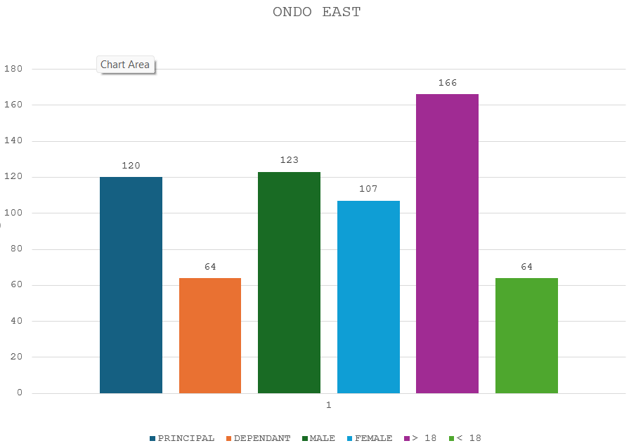

Key Insights:

Total Enrollees in GH BOLORUNDURO: 174

Total Enrollees in PHC OWENA BRIDGE: 10

Total Enrollees across both facilities: 184

1. GH bolorunduro accounts for 94.6% of total enrollees in ondo east while PHC owena bridge accounts for 5.4% which shows GH bolorunduro is a bigger facility.
2. The ratio of principal to dependant is 2:1 with the principals having a significant higher. count
3. There is just slight difference between between males and females with males having a higher count.
4. The age distribution shows a significant higher number of individuals above 18 years (166) compared to those below 18 years (64) indicating need for a more adult focused care

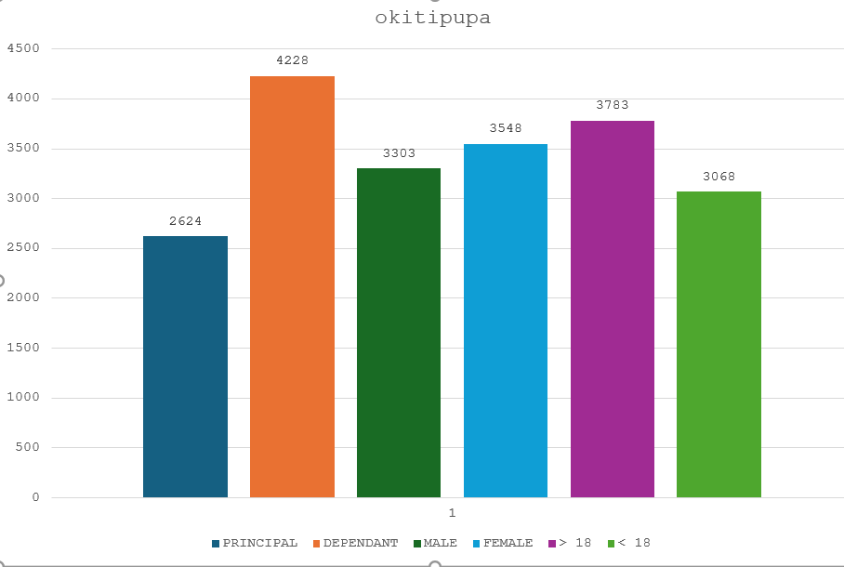**OKITITPUPA**

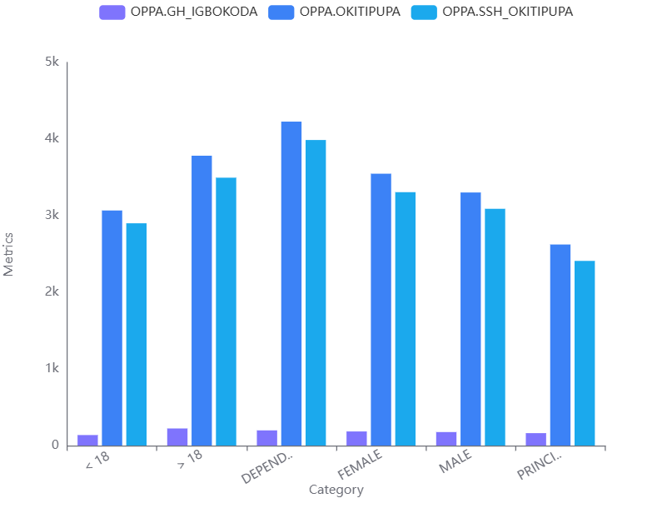

**KEY INSIGHTS:**

1. Total enrollees were 6852 where GH igbokoda accounted for 5.25%, SSH okitipupa 93.37%, PHC ode aye accounts 1.05%
2. SSH okitipupa is the main facility in the okitipupa local government.
3. Across all facilities there was more dependant that principal which indicate a family focused care.
4. There was just a slight difference between the male and female count across all facilities.
5. There was just a slight difference between the those above 18 and those below 18 across all facilities with those above 18 being more with a total figure of 3783.

**OWO**

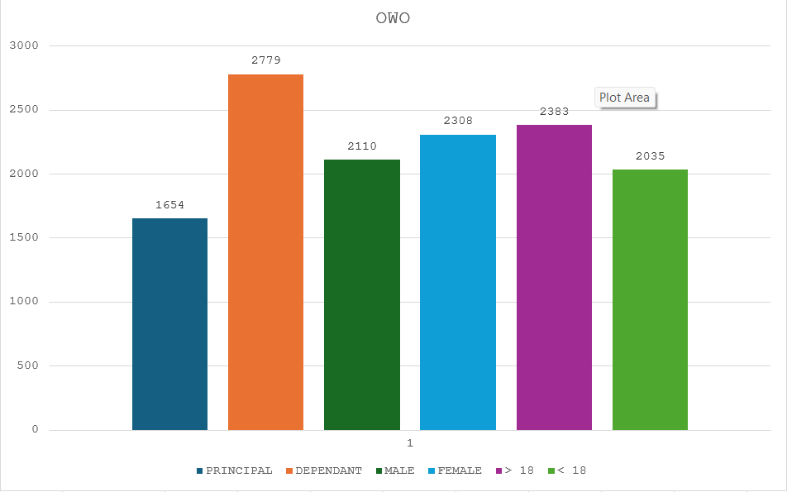

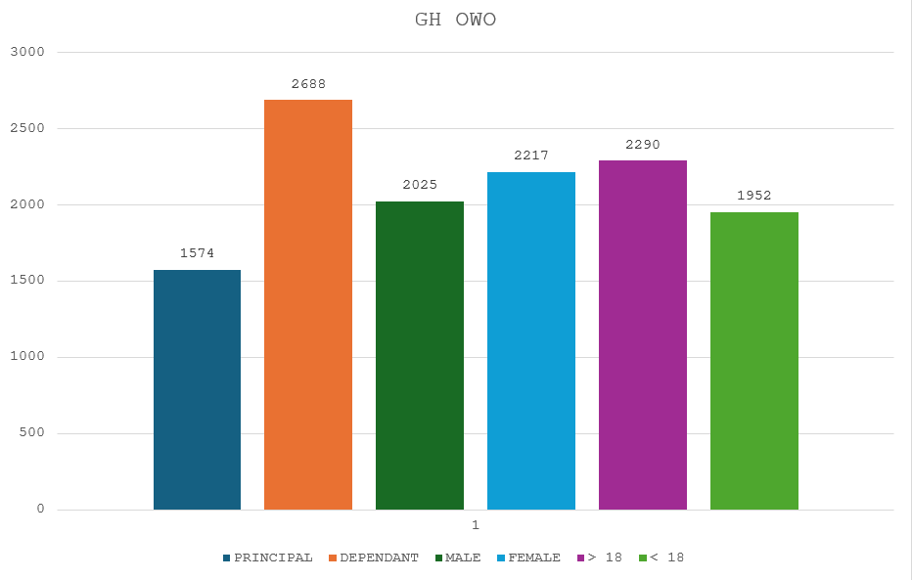

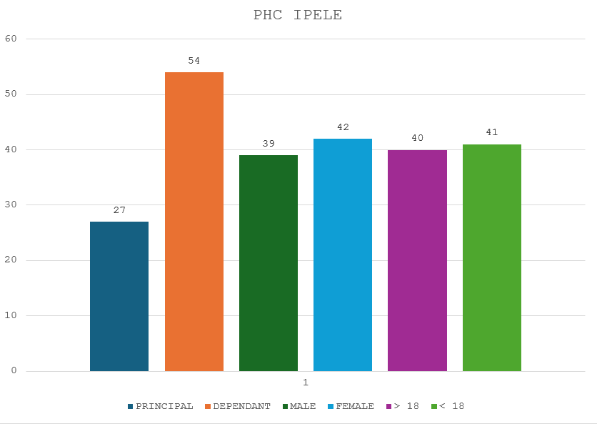

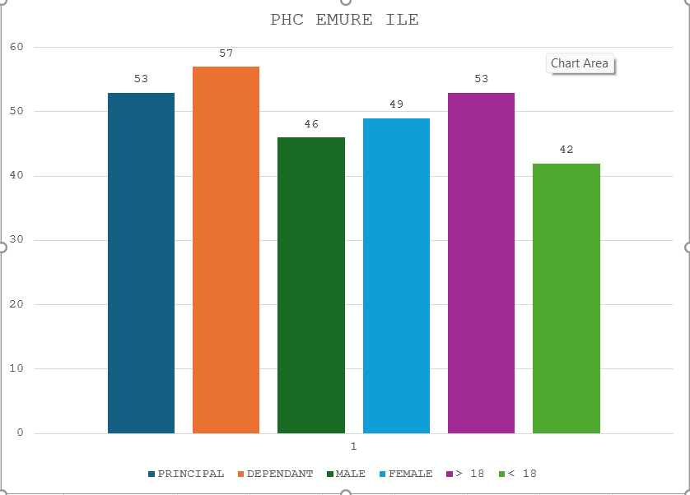KEY INSIGHTS:

1. Total enrollees are 4433 with GH owo having 96.1% which takes up most of the enrollees of the owo local government.
2. PHC emure ile takes up 2.48% of total enrollees while PHC ipele takes up 1.82% of total enrollees
3. Across all facilities there was more dependant that principal which indicate a family focused care.
4. There was just a slight difference between the male and female count across all facilities.
5. There was just a slight difference between the those above 18 and those below 18 across all facilities with those above 18 being more with a total figure of 2290.

**OSE**

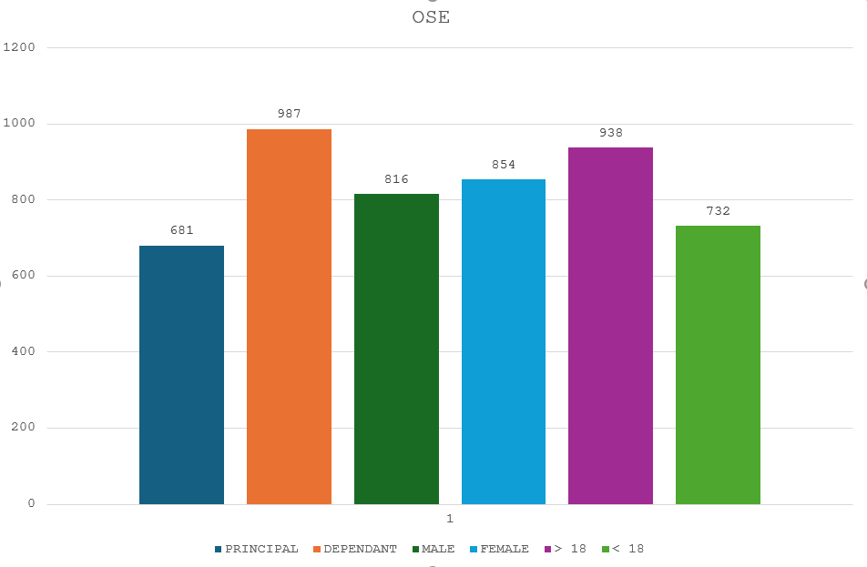

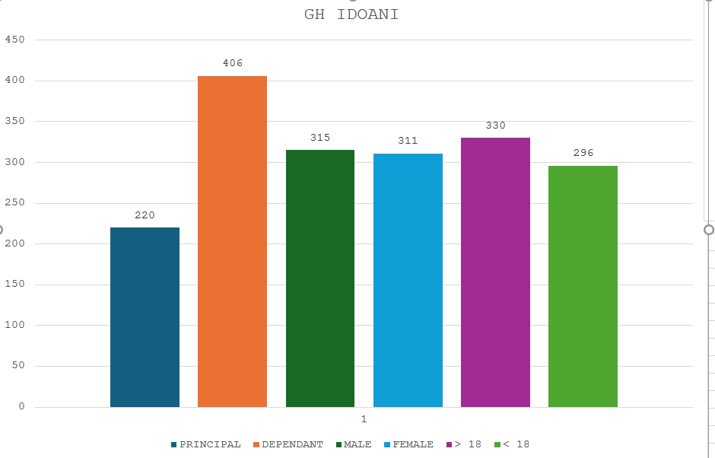

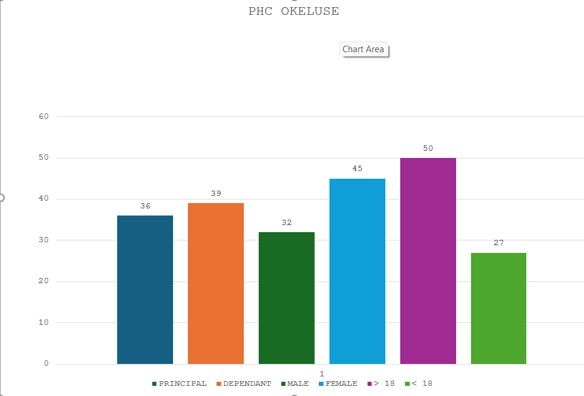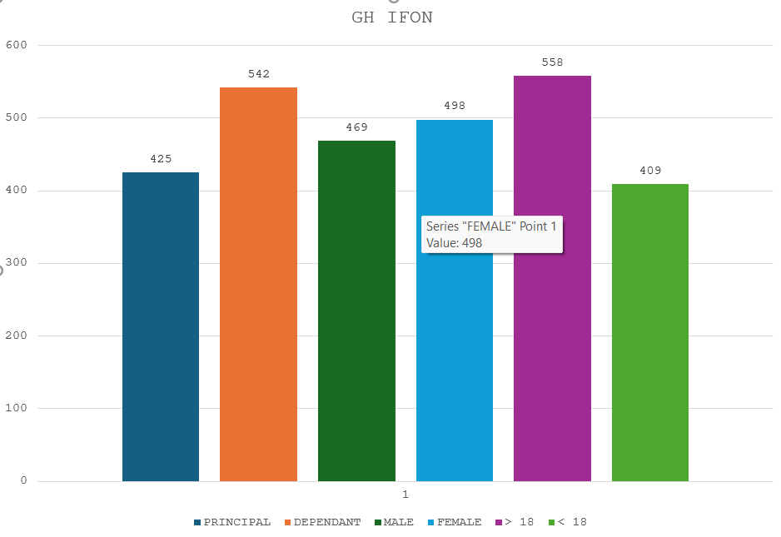

KEY INSIGHTS:

1. Total enrollees 1668 with GH idoani taking 37.5% and GH ifonss taking 59.9 % which indicates both facilities are well equipped and most accessible to the community.
2. PHC okeluse takes up 4.49% of total enrollees at OSE LGA.
3. Across all facilities there was more dependant than principal except in PHC okeluse where there was just slight difference.
4. There was just a slight difference between the male and female count across all facilities.
5. There was just a slight difference between the those above 18 and those below 18 across all facilities with those above 18 being more with a total figure of 938.

**ONDO WEST**

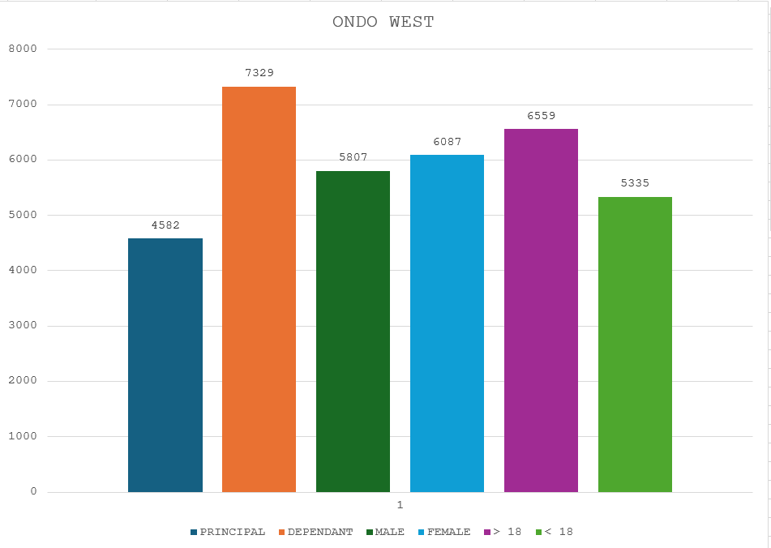

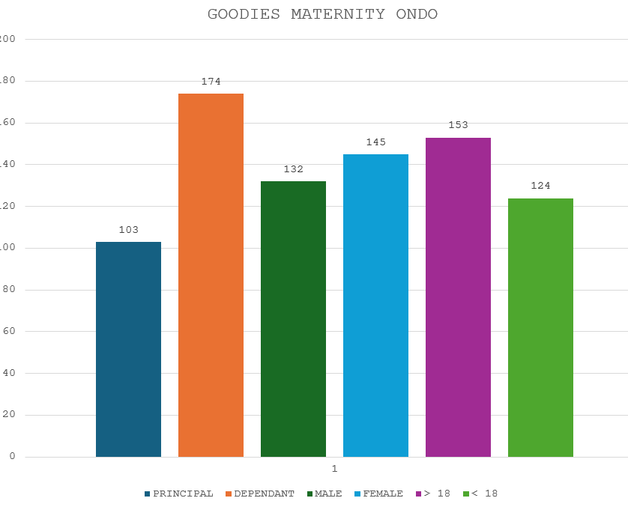

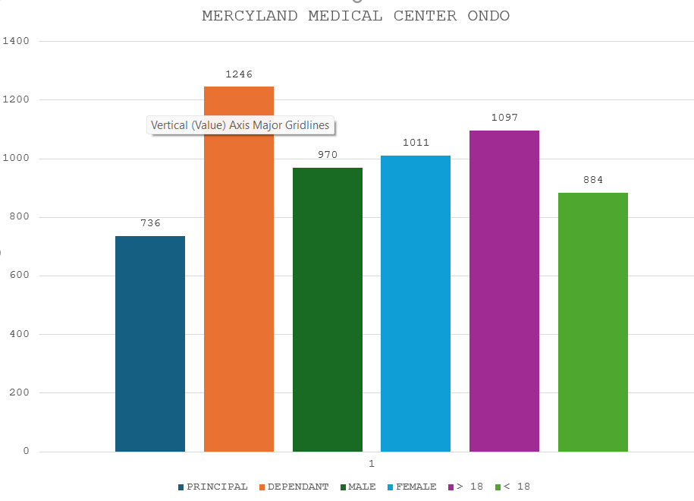

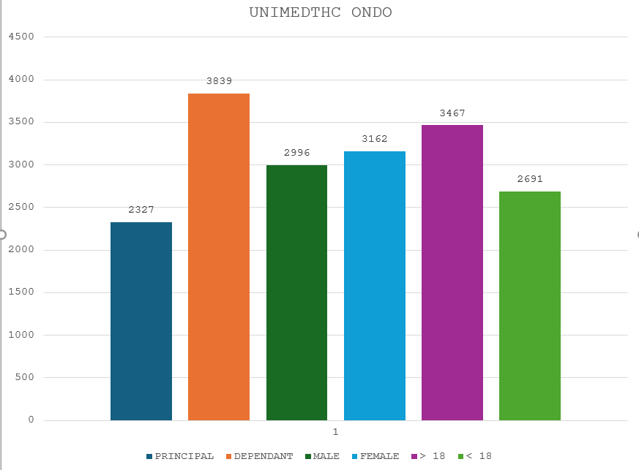

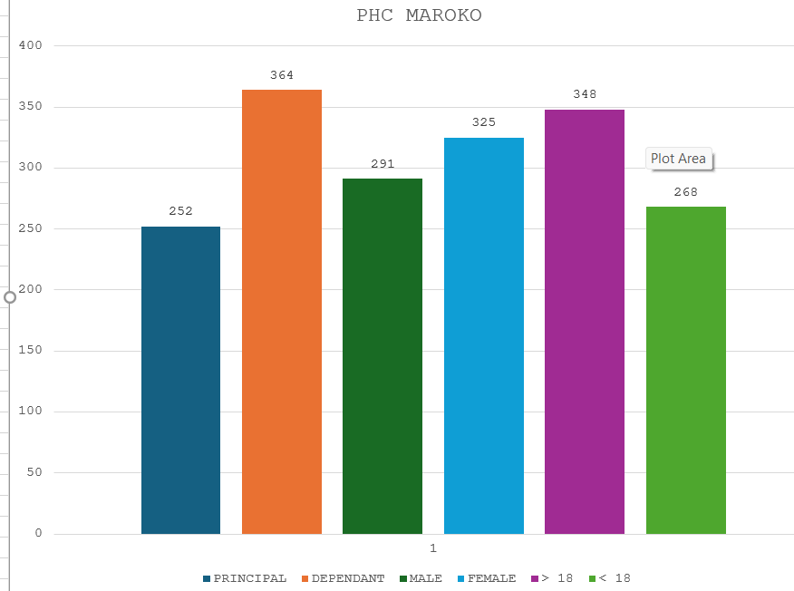

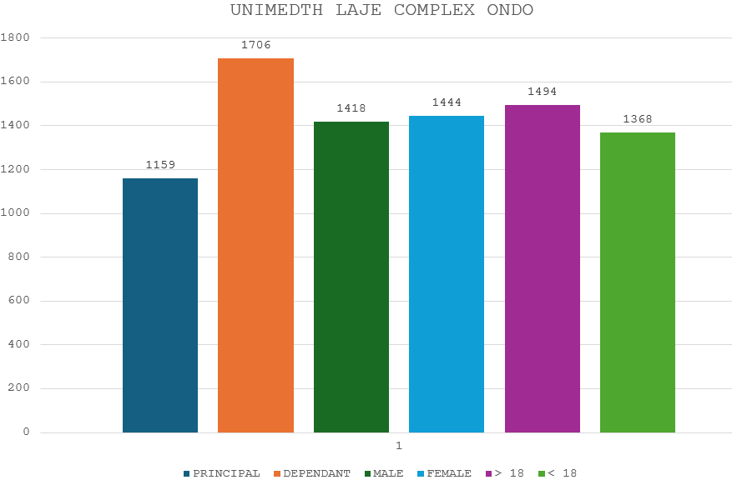KEY INSIGHTS:

1. Total enrollees in the Ondo west LGA is 11911.
2. Unimedth Ondo accounted for the largest proportion of total enrollees with a proportion of 51.76%, followed by Unimedth Laje 24%, then mercyland medical center covering about 16.6%, goodies maternity covering the lowest percentage with 2.32%.
3. Across all facilities there was more dependant than principal indicating a family focused care.
4. There was just a slight difference between the male and female count across all facilities.
5. There was just a slight difference between the those above 18 and those below 18 across all facilities with those above 18 being more with a total figure of 6398.

**ESE ODO**

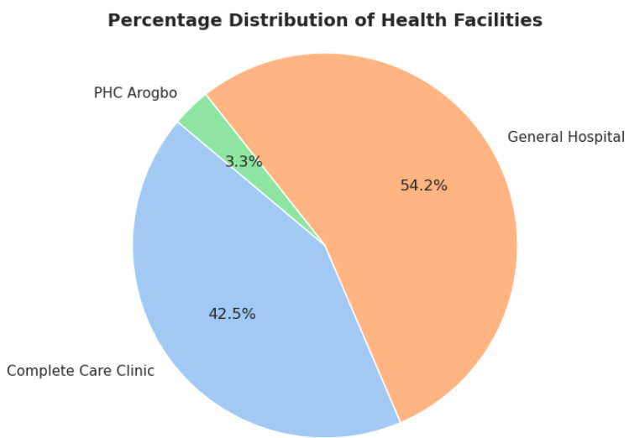

Key insights:

1. Total enrollees in ese-odo LGA is 891
2. General hospital igbekebo has the largest proportion of enrollees, followed by complete care clinic agadagba, then the comprehensive health center Arogbo.
3. Across all facilities there was more principal than dependants xcept the complete care clinic which had slightly mire dependants.
4. There was significantly difference between the total male and female count.
5. There was just a significant difference between the those above 18 and those below 18 across all facilities with those above 18 being more with a total figure of 582

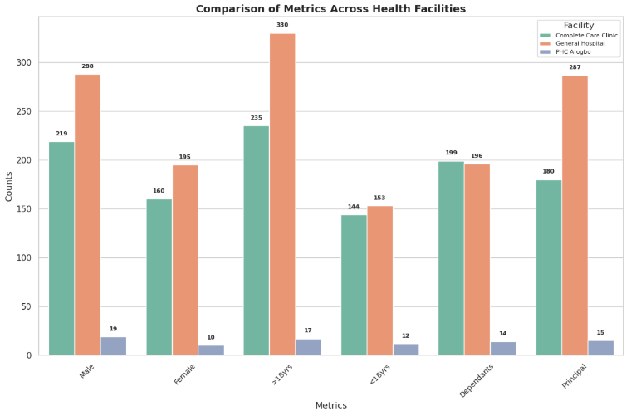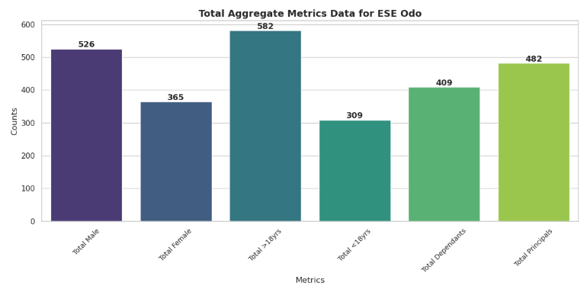

**ILAJE**

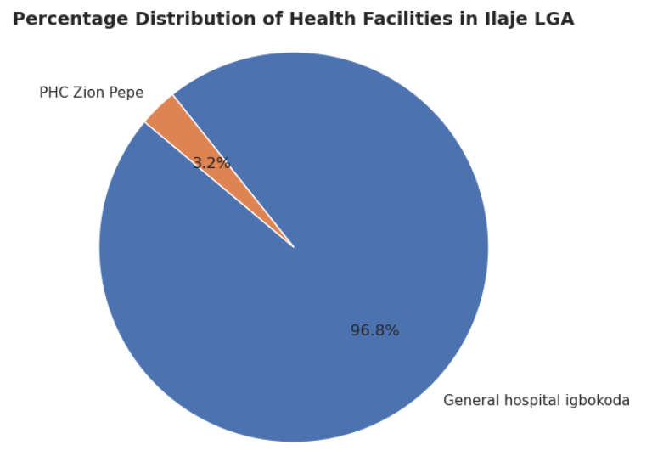

Key insight:

1. Total enrollees in ilaje LGA is 3977
2. General hospital igbokoda has a significantly larger proportion of enrollees compared to PHC Zion pepe which indicates that the community has more trust in the general hospital.
3. Across all facilities there was more dependants than principal indicating a family focused insurance. There was significantly difference between the total male and female count.
4. There was a significant difference between the those below 18 and those above 18 across all facilities with those below 18 being more with a total figure of 2111.

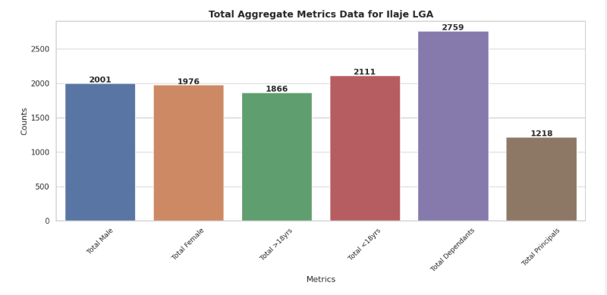

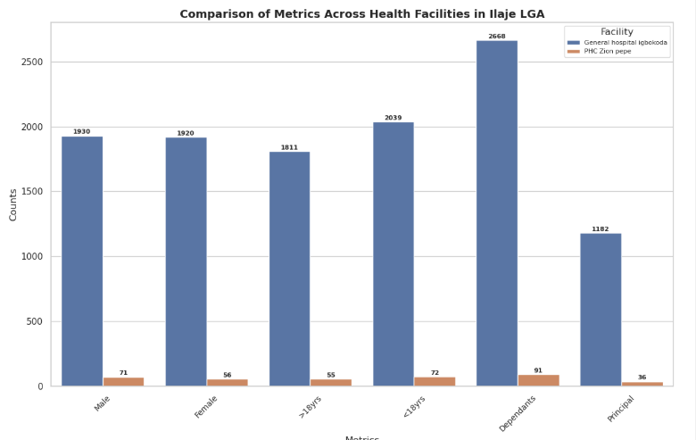

**IDANRE**

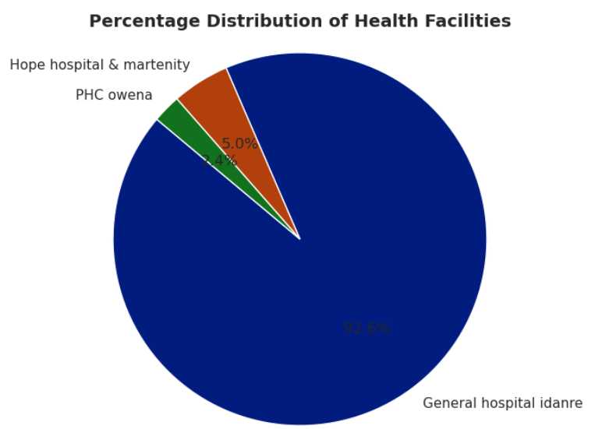

1. Total enrollees in Idanre LGA is 1267
2. General hospital idanre has the largest proportion of enrollees, followed by Hope hospital and maternity, then the PHC owena.
3. Across all facilities there was more dependants than principal enrollees.
4. There was significantly difference between the total male and female count with the females being more.
5. There was a significant difference between the those above 18 and those below 18 across all facilities with those above 18 being more with a total figure of 770.

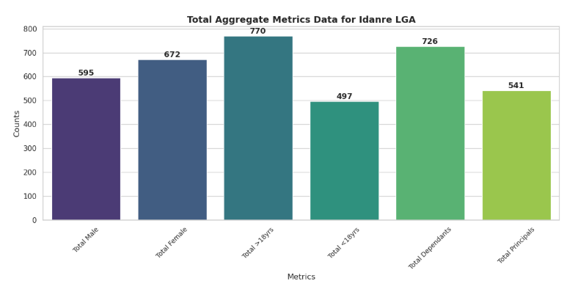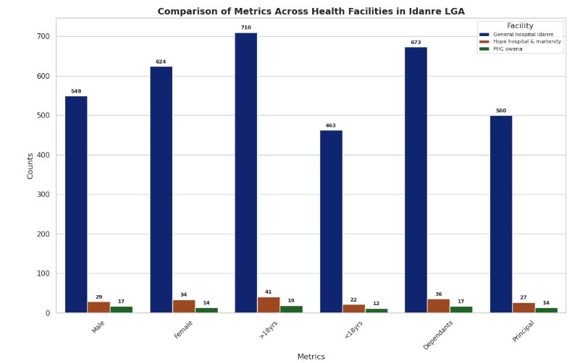

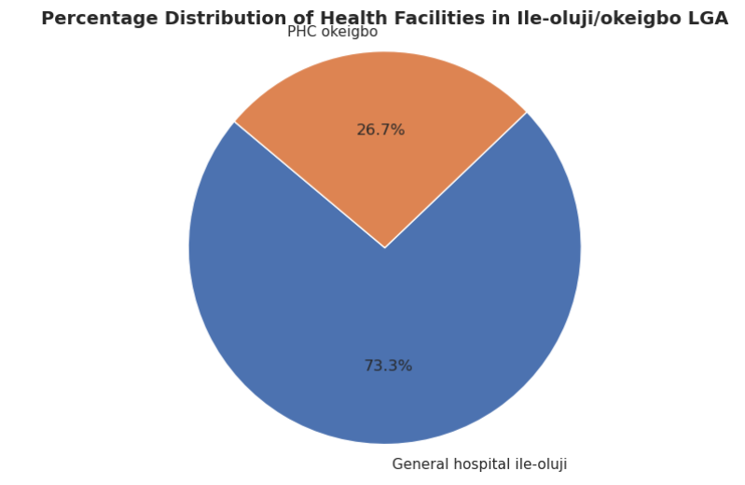**ILE OLUJI/OKEIGBO**

Key Insights:

1. Total enrollees in Ile-oluji/Okeigbo LGA is 2443
2. General hospital Ile-oluji has the larger proportion of enrollees compared to PHC okeigbo.
3. There were significantly more principal in GH hospital ile-oluji while there were more dependats at the PHC okeigbo.
4. There is slightly difference between the total male and female count with the males being more.
5. There is slight difference between the those above 18 and those below 18 across all facilities with those below 18 being more with a total figure of 1346.

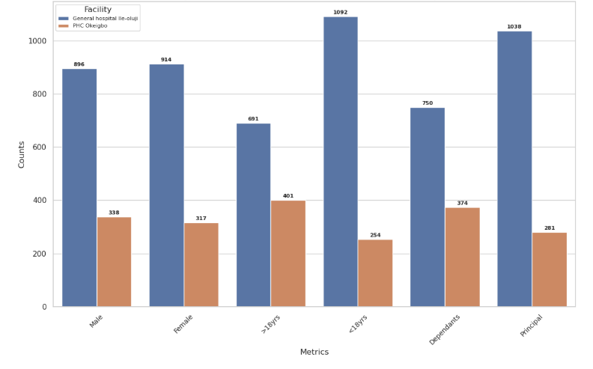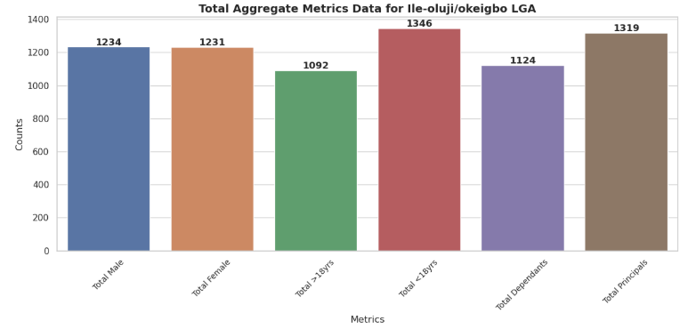

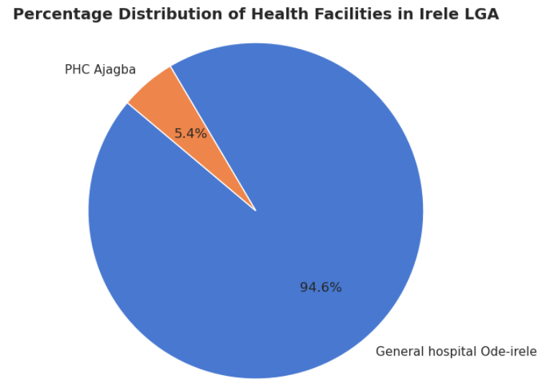**IRELE**

Key insights:

1. Total enrollees in Irele LGA is 1974
2. General hospital Ode-irele has the larger proportion of enrollees compared to PHC Ajagba indicating better access and trust for the general hospital.
3. There were more dependants across both facilites showing a family-oriented health insurance.
4. There is slightly difference between the total male and female count with the males being more.
5. There is slight difference between the those above 18 and those below 18 across all facilities with those above 18 being more with a total figure of 1035.

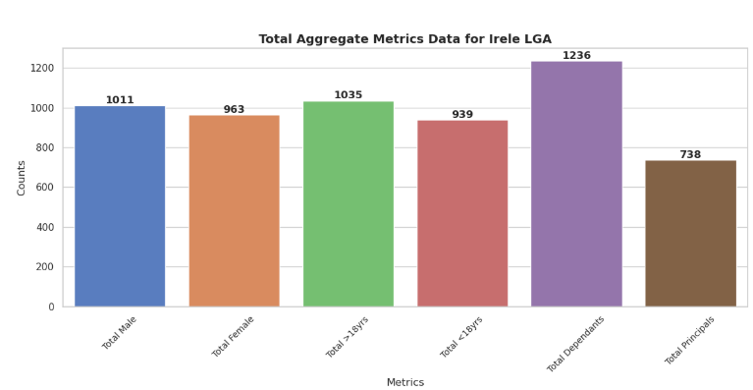

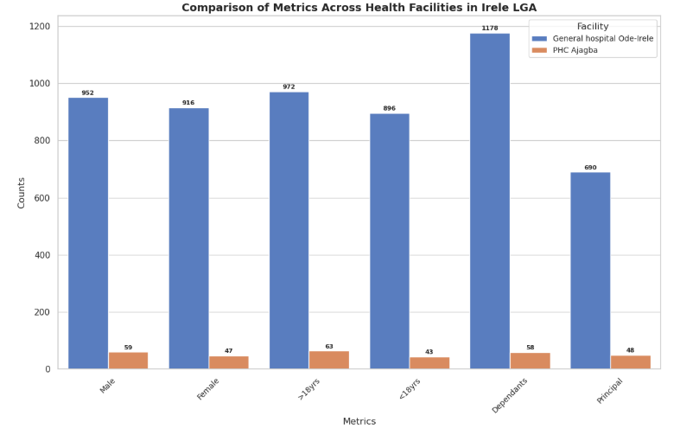

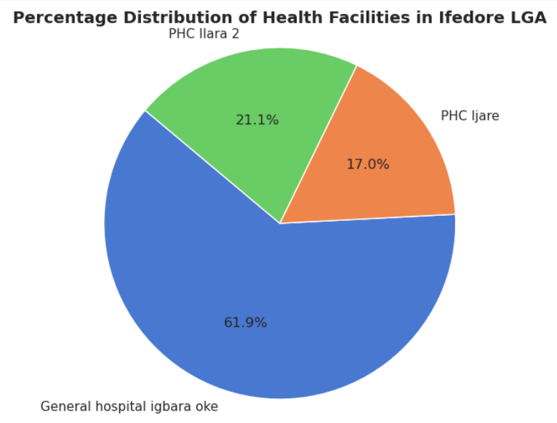**IFEDORE**

Key insights:

1. Total enrollees in Ifedore LGA is 1521
2. General hospital igbara oke has the larger proportion of enrollees compared to the two other primary health care center.
3. There were more dependants across all the facilities except for PHC Ilara 2.
4. There is slightly difference between the total male and female count with the males being more.
5. There is significant difference between the those above 18 and those below 18 across all facilities with those above 18 being more with a total figure of 870.





